**JAPANESE ASSIGNMENT**

**18LEH105J**

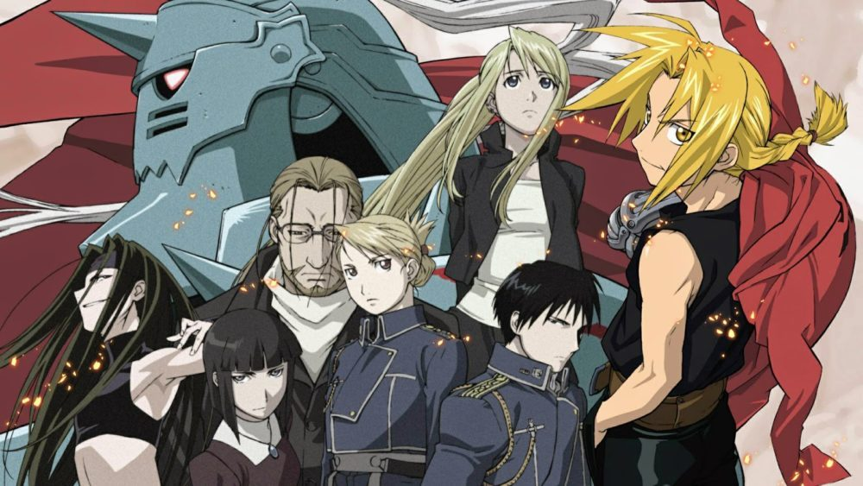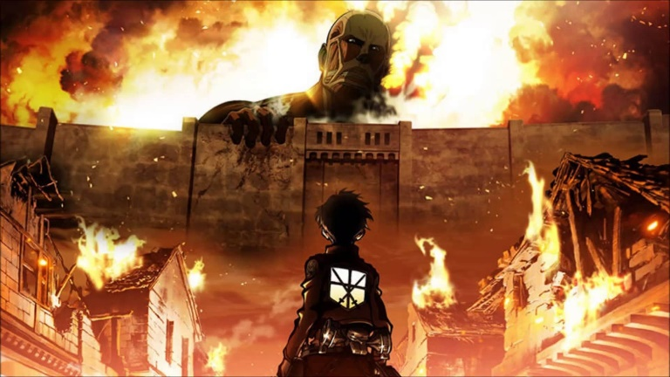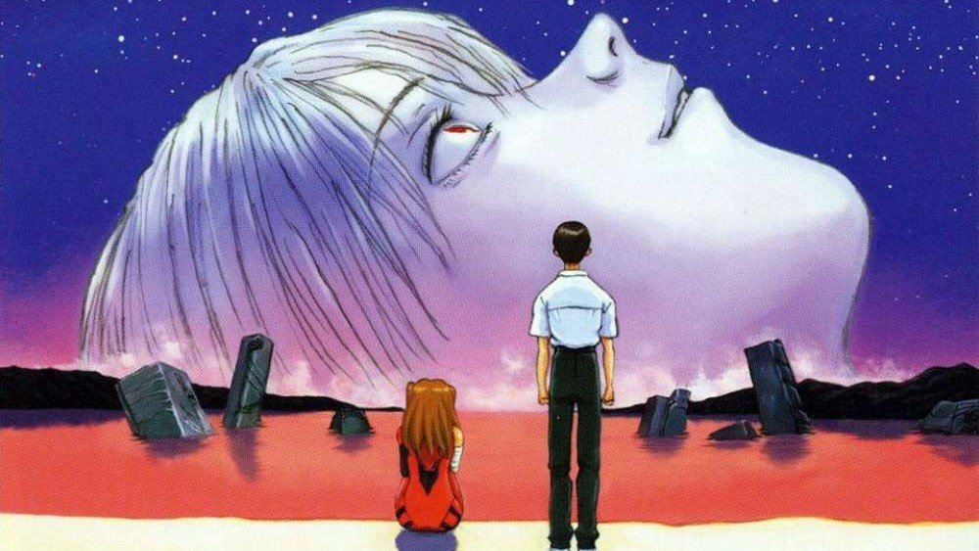

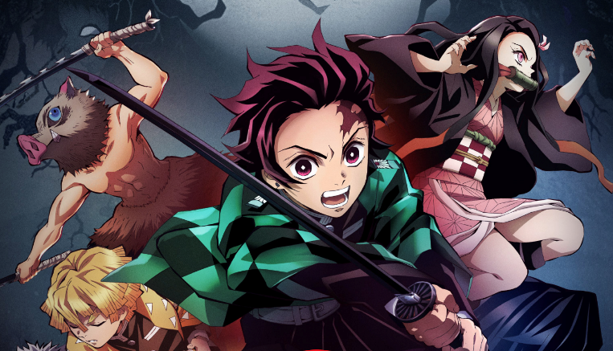

**ANIME & MANGA**

# **BY S. KUNAL KESHAN – RA2011004010051 – ECE A**

**WHAT IS ANIME & MANGA?**

Anime is a style of animation originating in Japan that is characterized by stark colourful graphics depicting vibrant characters in action-filled plots often with fantastic or futuristic themes. It is commonly known that most anime series originate or adapt from manga of that particular genre.

Eg: Shingeki no kyojin, kimetsu no yaiba, kakushigoto, and a lot other.

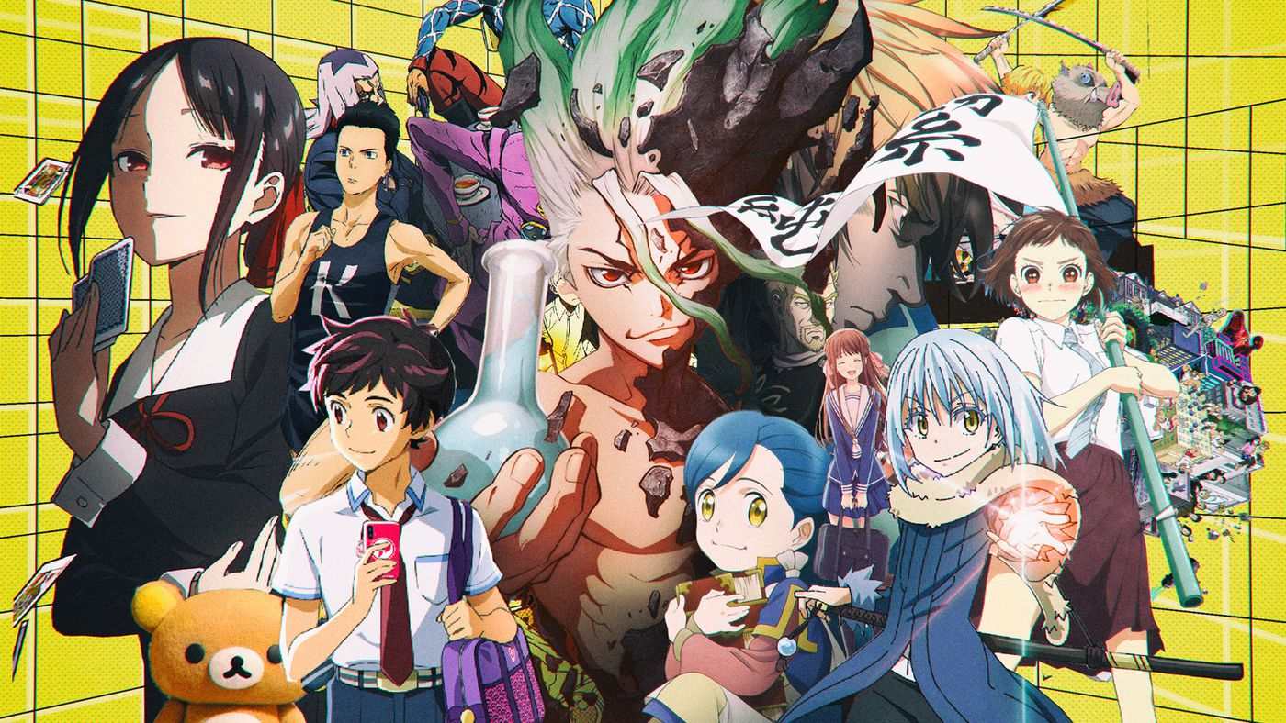

Manga is a style of Japanese comic books and graphic novels, typically aimed at adults as well as children. What is unique about manga is the way many manga authors are able to depict human emotions through their characters in such a manner that many people around the world are able to relate to and catch their attention in wanting more about it is truly astonishing.

Eg: JoJo’s Bizarre Adventures, Shingeki no kyojin, Tokyo Ghoul and a lot other.

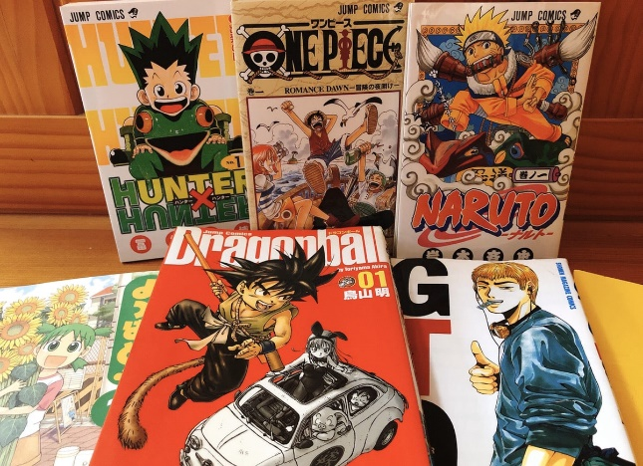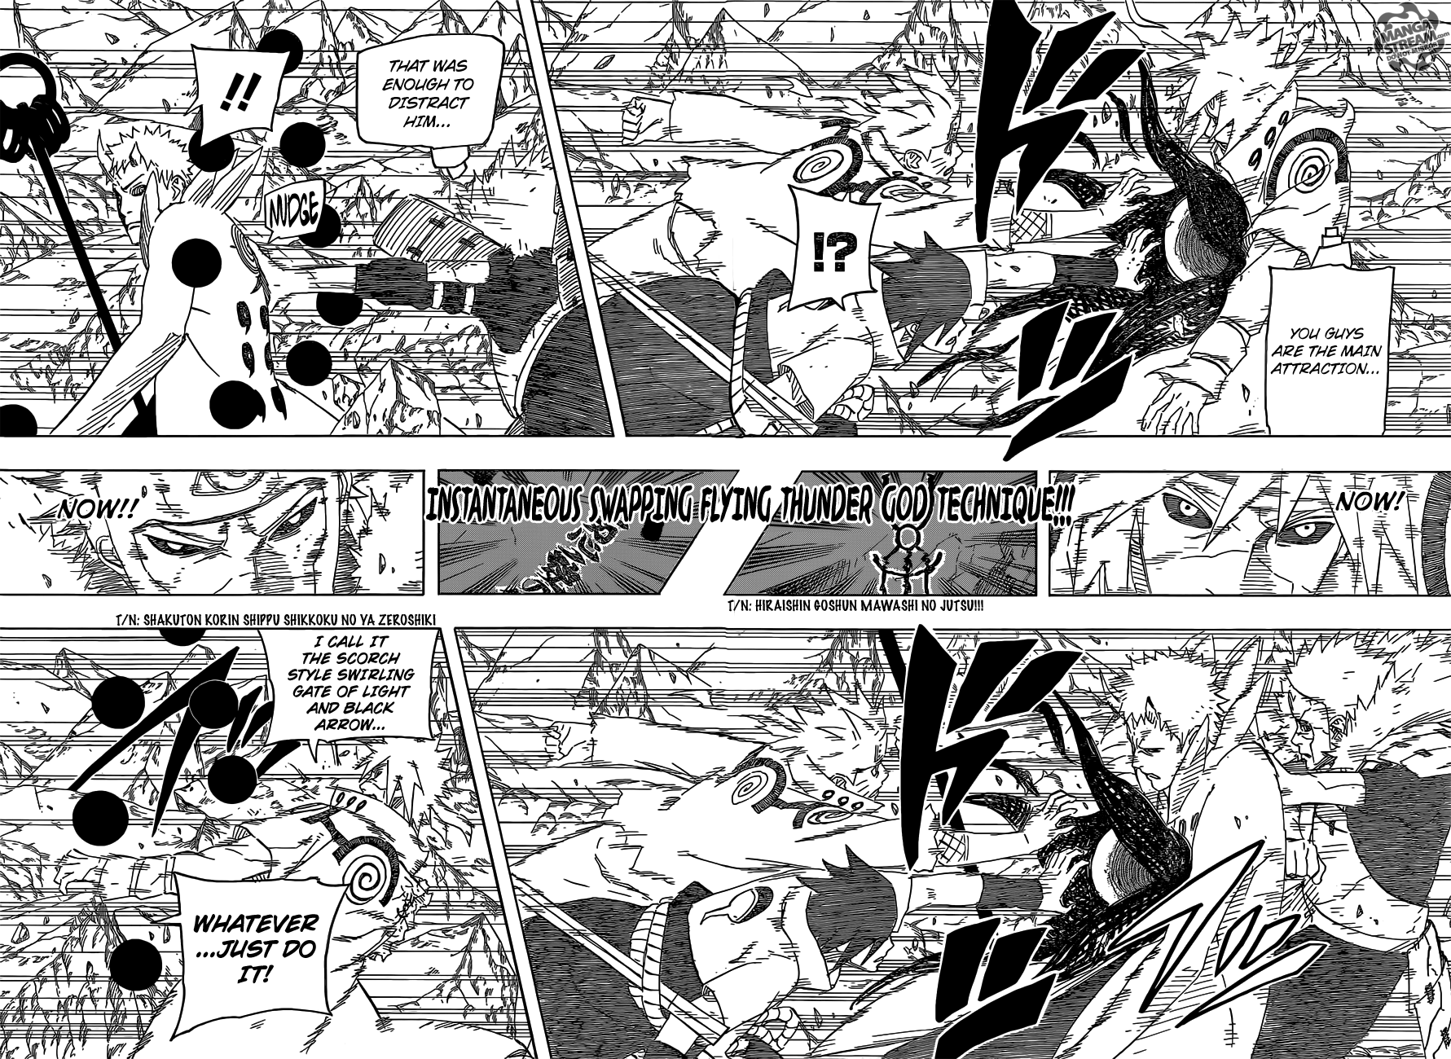

**WHEN DID THEY ORIGINATE?**

Manga is said to originate from scrolls dating back to the 12th and 13th centuries. During the Edo period (1603-1867), another book of drawings, Toba Ehon, embedded the concept of manga. The word first came into common usage in the late 18th century with the publication of such works as Santō Kyōden's picturebook Shiji no yukikai (1798), and in the early 19th century with such works as Aikawa Minwa's Manga hyakujo (1814) and the celebrated Hokusai Manga books (1814–1834) containing assorted drawings from the sketchbooks of the famous ukiyo-e artist Hokusai who lived from 1760–1849. Rakuten Kitazawa (1876–1955) first used the word "manga" in the modern sense. Another example of the first half of the 18th century might be "Dehōdai mucharon" of 1822 with prints of Hiroshige, who illustrated several books of this kind between 1820 and 1837.

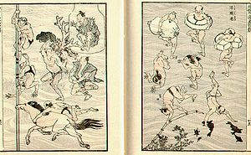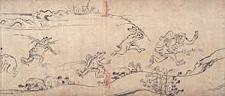

After World War II, Japanese artists subsequently gave life to their own style during the occupation (1945–1952) and post-occupation years (1952-early 1960s), when a previously militaristic and ultranationalist Japan was rebuilding its political and economic infrastructure. Although Allied occupation censorship policies specifically prohibited art and writing that glorified war and Japanese militarism, those policies did not prevent the publication of other kinds of material, including manga. Furthermore, the 1947 Japanese Constitution (Article 21) prohibited all forms of censorship. One result was the growth of artistic creativity in this period. In the forefront of this period are two manga series and characters that influenced much of the future history of manga. These are Osamu Tezuka's Mighty Atom (Astro Boy in the United States; begun in 1951) and Machiko Hasegawa's Sazae-san (begun in 1946).

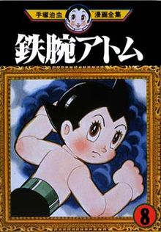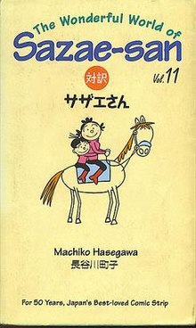

According to Natsuki Matsumoto, the first animated film produced in Japan may have stemmed from as early as 1907. Known as Katsudō Shashin (活動写真, "Activity Photo"), from its depiction of a boy in a sailor suit drawing the characters for katsudō shashin, the film was first found in 2005.

Click to view video: <https://upload.wikimedia.org/wikipedia/commons/2/2d/Katsud%C5%8D_Shashin_%281907%29.webm>

Toei Animation and Mushi Production was founded and produced the first color anime feature film in 1958, Hakujaden (The Tale of the White Serpent, 1958). It was released in the US in 1961 as well as Panda and the Magic Serpent. After the success of the project, Toei released a new feature-length animation annually.

In 1995, Hideaki Anno wrote and directed the controversial anime Neon Genesis Evangelion. This show became popular in Japan among anime fans and became known to the general public through mainstream media attention. It is believed that Anno originally wanted the show to be the ultimate otaku anime, designed to revive the declining anime industry, but midway through production he also made it into a heavy critique of the subculture. It culminated in the successful but controversial film The End of Evangelion which grossed over $10 million in 1997.

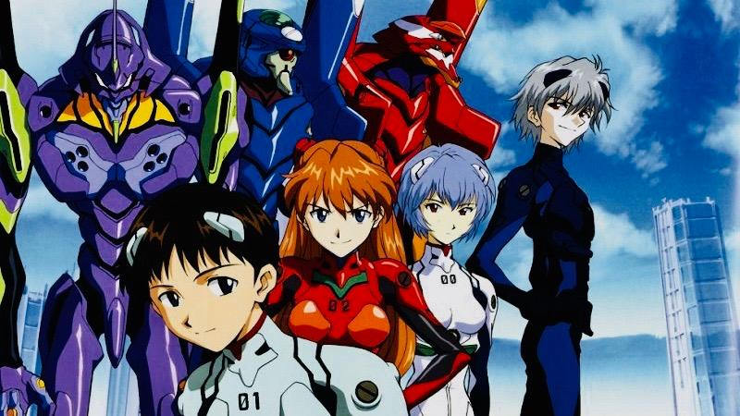

Demon Slayer: Kimetsu no Yaiba the Movie: Infinity Train became the highest-grossing Japanese film and one of the world's highest-grossing films of 2020. It's also fastest grossing film in Japanese cinema, because in 10 days it made 10 billion yen ($95.3m; £72m). It beat the previous record of Spirited Away which took 25 days.

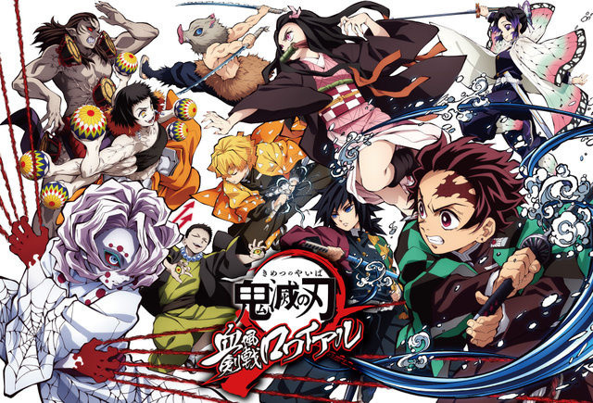

**HOW FAMOUS IS MANGA & ANIME?**

There are millions of anime and manga fans all around the world and what’s even more astonishing is that how much commercialized it has become in various parts of the world, from Anime-con and Comic-cons to literal mega structures dedicated to anime characters. Some famous examples of interconnected anime and manga are with the Japanese community is given below.

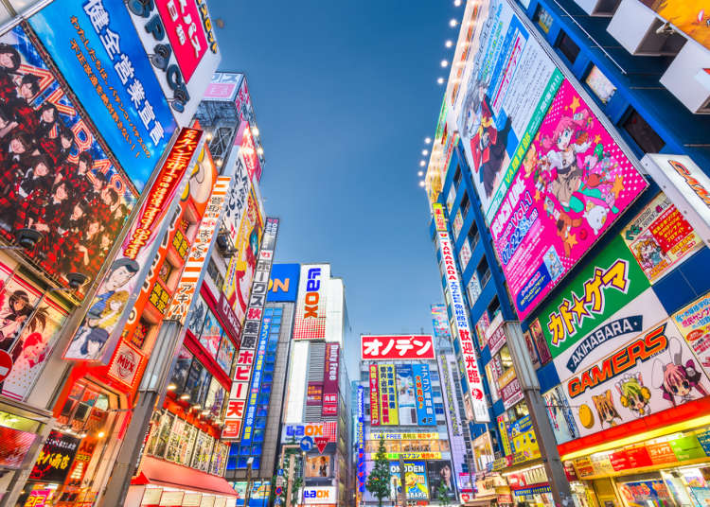 **Akihabara**

Dubbed as the anime and manga capital of Japan, Akihabara is a vibrant Tokyo district that has an abundance of electronics shops, anime stores, maid cafes, gaming venues, and more.

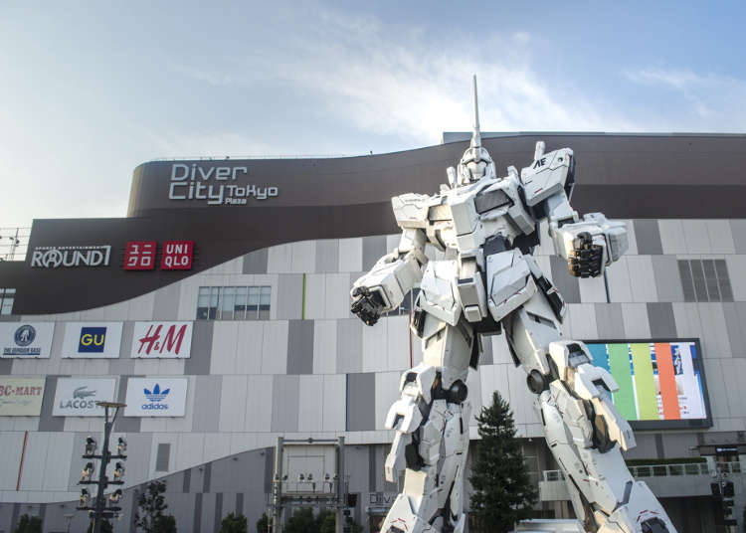

**Gundam Front Tokyo**

Best known for its enormous 18-metre tall Gundam robot, Gundam Front Tokyo is a store and museum that offers merchandise and attractions based on the Gundam franchise.

**Pokemon Center**

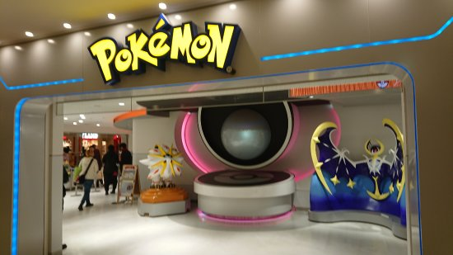For official and original Pokemon video games, cards, and other goodies, the Pokemon Center is the place to be. In addition to the store, it also has a teaching room where visitors can learn how to play the Pokemon card game.

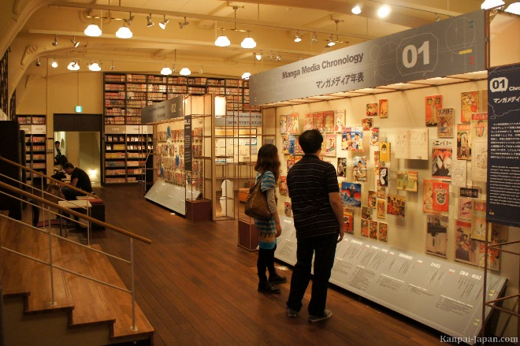**Kyoto International Manga Museum**

With its massive collection of old and recent manga series, the Kyoto International Manga Museum features walls and walls of shelves filled with manga volumes. It also hosts temporary exhibitions of works of different manga artists, both current and from the past.



**Tokyo Character Street**

Found below Tokyo Station, Tokyo Character Street is an underground shopping haven for anime and fans. It has numerous shops and stalls that sell various popular anime and manga character merchandise.

**BIBLIOGRAPHY**

* <https://www.merriam-webster.com/dictionary/anime>
* <https://www.japanrailpass.com.au/top-10-places-to-visit-for-anime-and-manga-fans/#:~:text=Dubbed%20as%20the%20anime%20and,%2C%20gaming%20venues%2C%20and%20more>.
* <https://en.wikipedia.org/wiki/History_of_manga#:~:text=World%20War%20II-,Manga%20is%20said%20to%20originate%20from%20scrolls%20dating%20back%20to,embedded%20the%20concept%20of%20manga.&text=Rakuten%20Kitazawa%20(1876%E2%80%931955),manga%22%20in%20the%20modern%20sense>.
* <https://en.wikipedia.org/wiki/History_of_anime>